
LEARNING LETTER
Class 4
Miss Carnelley, Mr Grafton, supported by Mrs Webb
Summer 1 2025-2026
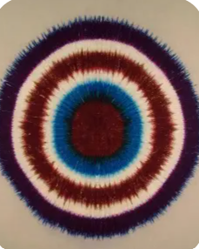
NEW TOPIC – Art – Abstract art, Chalk pastel and fabric dyes
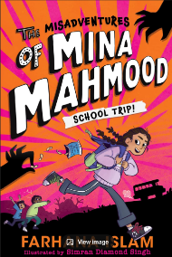
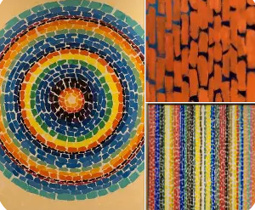
This term the children will be learning about two wonderful artists that have used chalk pastels and tie dye to form their art work. We will be looking at Alma Thomas who was an African-American artist who used chalk pastel dashes and bright colours to create ‘radiating circles’ and ‘waterfall lines’ in her art. We will also look at Michael Phelan, another American artist who uses tie dye to create concentrical circles using different contrasting colours. Class 4 will create their own inspired pieces of artwork, ready for the Bramley Vale Art Showcase!
The Annual Big Read Book Cup
We held our book cup, at the beginning of the half term, to decide which book we would like to be our class book. We judge this on the blurb, not the front cover. We chose…

SUPPORTING LEARNING AT HOME
Thanks for the continued support in reading at home last half term. It is still vitally important that all children read at home, and your support is appreciated moving into Summer 1. If you can continue to read and sign your child’s reading diary 3 or 4 times a week, this soon adds up, and your child will benefit hugely.
Each daily read contributes to their Reading Olympics tally.

P.E.
Our PE days are Monday and Wednesday. Swimming has now finished for the year they will need PE kit on for both days. If you have any questions about this, please let me know.

Activities
There will be lots happening again throughout the half term. We will be taking part in the ‘Big Walk’ fundraising event, sporting events and showcasing the school’s wonderful artwork, at an art gallery held in the school hall. Class 4 will also be going on another wonderful school trip to Sheffield. This will be to go and visit Weston Park Museum, where the children will have the opportunity to fabric print. Class 4 will design their own printing blocks and print their image onto a large banner. A great half term ahead!

THIS TERMS VALUE
This terms value is ‘Creativity’. We will be stressing the need to maintain a positive approach to learning and life – trying to see the good in each experience. We will also aim to help spread positivity throughout the school and wider community.

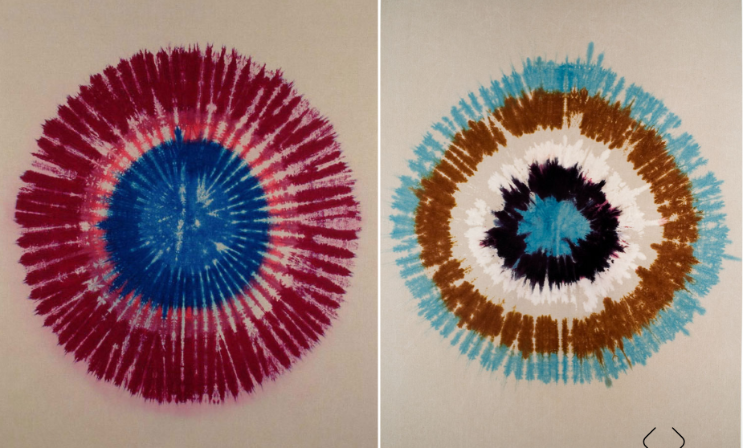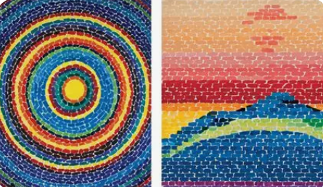

HOMEWORK CHALLENGES
CLASS 4 Summer 1 2026
Miss Carnelley, Mr Grafton, supported by Mrs Webb
This term is Art. For your homework, you can choose which activity to complete. For some of them, you could record your results electronically, or the finished project could come to school. Remember, it does not need to be here until nearer the half term holidays so have a think and take your time.
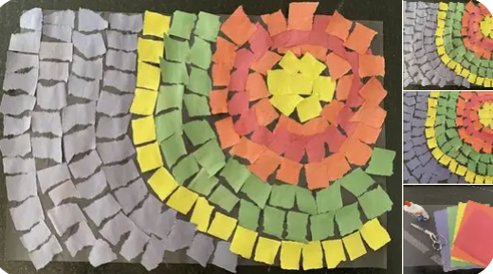  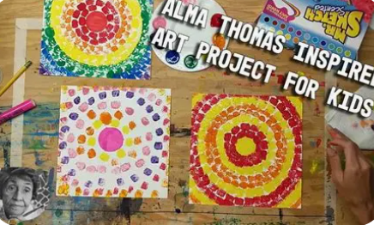 | 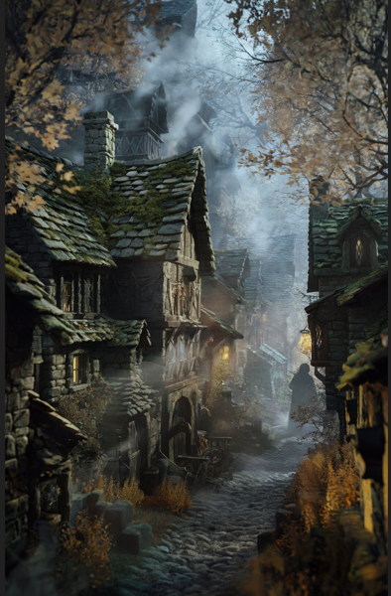 | 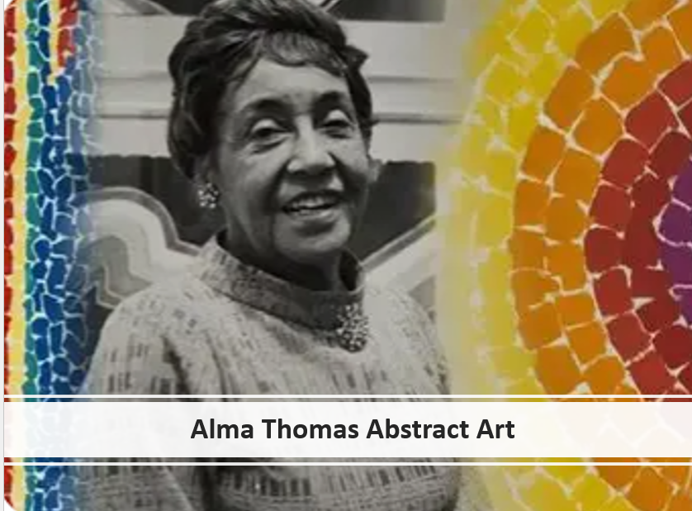
Art – Alma Thomas  Can you create an Alma Thomas art piece, using dashes or similar?  We have used chalk pastels in class, but can you use something different?  You can use collage, paint, recycling collage, anything that looks likes the dashes to recreate a circle or line piece of artwork inspired by Alma Thomas.  You can use chalk as well if you wanted to create another one at home. | English- Setting description  This half term we are concentrating on story writing and in the first half of the term writing setting and character descriptions, using expanded noun phrases and fronted adverbials.  Can you write a setting description for either this setting in the picture or a setting you have picked?  Bring your setting picture in, or I will find it to put on our homework display. | Art – Fact file (poster or PowerPoint)  Can you research Alma Thomas and create an artistic and factual poster about Alma Thomas and what she has achieved. You can even add her artwork.  This could also be made into a power point or word document.

