
LEARNING LETTER
Class 3
Miss Palmer, Mrs Brown and Mrs Hopkinson
Summer Term 1 2026
CRAVE CURRICULUM: Art – My Imaginary Garden

Welcome back to Summer 1 in Class 3!

Hello, everyone! My name is Miss Palmer and I am so excited to be joining Class 3. The whole of the Class 3 Team hope you’ve had a great half-term and are ready for lots of fun and learning.

OUR SCHOOL VALUE THIS HALF TERM IS…Creativity.
It was lovely to meet all of the children at the end of last term. What a polite group they are! We will continue to focus upon manners and kindness throughout this term.
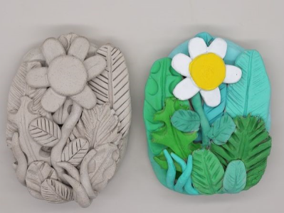
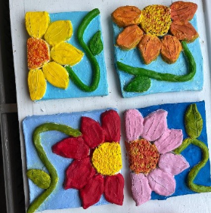


Our new topic of work this half-term will focus upon developing our skills as artists - we will be exploring a variety of artwork that uses the great outdoors as inspiration! The children will create their own fantasy gardens by designing and making clay sculptures of fascinating plants and creatures. I am sure their imaginations will help them to dream up some amazing creations.

In Literacy, we continue to focus on the theme of art. We will be exploring different ways that creativity can help us to feel happy and manage difficult emotions. By the end of this unit, we will all write guidebooks about how to support others that are feeling sad, worried or nervous. In PSED, we will be learning about changes to inspire us to help and care for ourselves and others.

In Maths, we will continue to learn about multiplication and division with a focus on mathematical fluently recalling the 2, 5 and 10 times tables. We’ll also be learning about other topics such as measurement, money, time and fractions.

SUPPORTING LEARNING AT HOME

Reading homework – Please do hear your children read their school reading books as often as you can. They are always so proud when they have learnt to read their book fluently. Becoming a fluent, confident reader takes lots of practise and the reading you all do at home makes a huge difference to your child in school.

Please write in your child’s diary for each read, as the children collect points towards the Reading Olympics awards for every read. 20 reads gain a bronze award, 30 a silver and 40 a gold and 50 is platinum – I am sure that every child in Class 3 will be super proud of themselves this half-term for achieving one of these awards! Children also collect Dojos for reading at home. The children who read regularly at home make the most progress in their phonics and reading development.

Topic homework – Please see the topic homework ideas grid for a selection of things for you to have a go at to develop your learning. Do remember to send homework to school, quality homework is worth 5 dojos!

Maths homework – Maths homework will be sent home on Fridays and is due to be completed by the following Friday.

GENERAL REMINDERS

PE continues to be on Tuesday and Thursday, and this half-term we will be learning how to play tag rugby. Please send your child to school in their correct PE kit and remove any earrings on PE days to ensure that they can participate safely.

