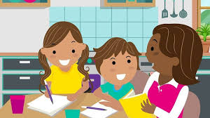

Home Learning Challenges Class 3
Miss Palmer, Mrs Brown and Mrs Hopkinson.
Summer Term 1 - 2026
This term’s New CRAVE Curriculum topic is Art!
TOPIC HOMEWORK: Please complete at least one of the challenges below to support learning in school. You may, however, choose your own if your child has a particular interest or idea. Please bring any work completed into school for us to share and display. Should you need extra resources such as paint or paper, do not hesitate to ask. Please also practice our topic vocabulary.
Art Target Vocabulary: Blend, Layer, Texture, Pattern, Form, Relief, Imprint and Compose.

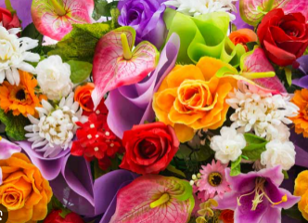
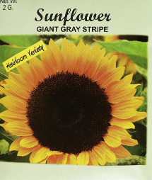
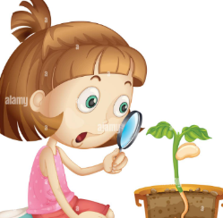

GET OUTDOORS! Go on a plant hunt in your garden, park or just out an about. Take a picture and then have a go at drawing up your pant accurately. Can you label the stem, leaves, petals and roots?
GET READING AND WRITING! Try following a set of instructions to grow your own Sunflowers (packs to be provided). Keep a diary of what you see changing day by day. Also, why not practise your measuring skills to see how tall your sunflower has grown!

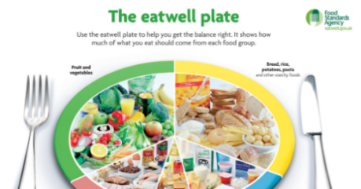
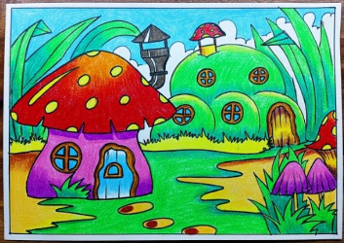
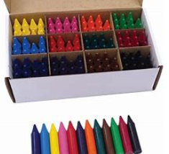

GET HEALTHY! Where do fruit and vegetables come from? Research where your favourite fruit or vegetable is grown and design a meal containing it.

GET CREATIVE! Draw your own fantasy garden. Include wild plants, glowing flowers, hidden creatures, and a backdrop. Have a go experimenting with mixing colours to make it more intriguing.

