Newsletter 2nd May 2025

Dear Parents, Carers and Friends of Bramley Vale Primary & Nursery School,
Summer Term is a GO!
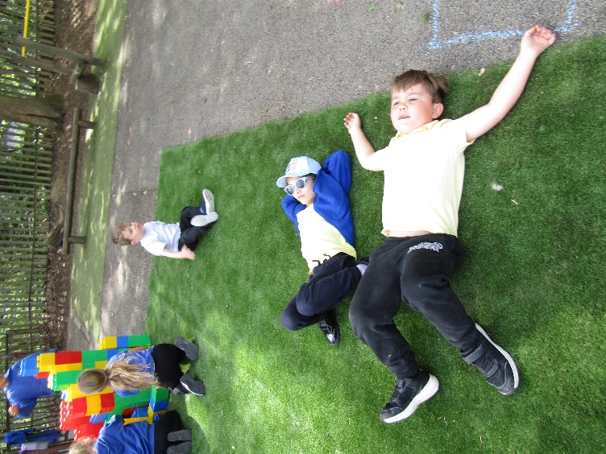
What glorious weather we have had this week! The trees are looking beautiful, and the blue bells are vibrant. Sadly, we cannot go down into the school woods to paint them this year. I am crossing everything that the school field will be ready, with grass, for our first event – Tough Runner!

Please send children with water bottles and caps/hats. There are areas of shade in school and we have the parasols to keep cool under too. Sometimes ‘chillin’ is the best plan when the temperatures rise!

Dojo Count Climbing
We have some big Dojo numbers building in school. We use dojos to reward all the positives the children demonstrate in and outside school. From keeping the cloakrooms tidy through to a positive attitude to learning, all are rewarded. Look out for stickers on school tops on a Friday and for Sapphire and Onyx a badge is presented. We also have a badge for those children who are ‘off the charts!’.

Award | Dojo Count | Award | Dojo Count
Diamond | 40 | Lapiz Lazuli | 240
Pearl | 80 | Ruby | 280
Amber | 120 | Emerald | 320
Opal | 160 | Sapphire | 360
Amethyst | 200 | Onyx | 400

Parents Evening
A very positive week of meetings with children, parents/guardians and teachers. The best outcomes happen when we all work together, which is why attending parent evenings is on our Home/School agreement. You now know what the targets are for your child and the progress needed as we head into the Summer Term. Thank you for your support and being 100% behind the children of BVPS.

Bramley Vale Stars!
Certificates and BADGES have been handed out in assembly and this half-term’s value was ‘CREATIVITY’. We love to see the school lanyards on a Friday so please have your children wear them on a Friday.
This week:
- Class 6 – Amelia Class 2 – Ivy
- Class 5 – Minuthi Class 1 – Margot
- Class 4 – Holly Lunchtime Award – Daniel
- Class 3 – Max Kindness Award – Lochlyn & Georgia W

Last week:
- Class 6 – Matt Class 2 – Frankie
- Class 5 – Olly Class 1 – None this week
- Class 4 – Lochlyn Lunchtime Award – Hughie
- Class 3 – Poppy Kindness Award – Nate

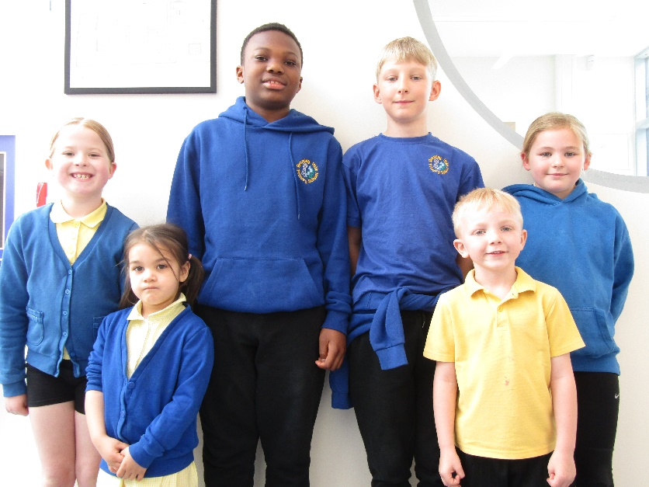
Reading Legends
Last half-term’s Reading Legends have all had their book vouchers and the Travelling Book Fair has been in school all week.

All children visited the Reading Olympics Board last week to see where they are talk about going ‘all out’ in the Summer Term to get on the board or move up a level.

If everyone gets on the board Mr Rumsby has promised the children a ‘day off’! Keep the reading going everyone!

Trim Trail Challenge
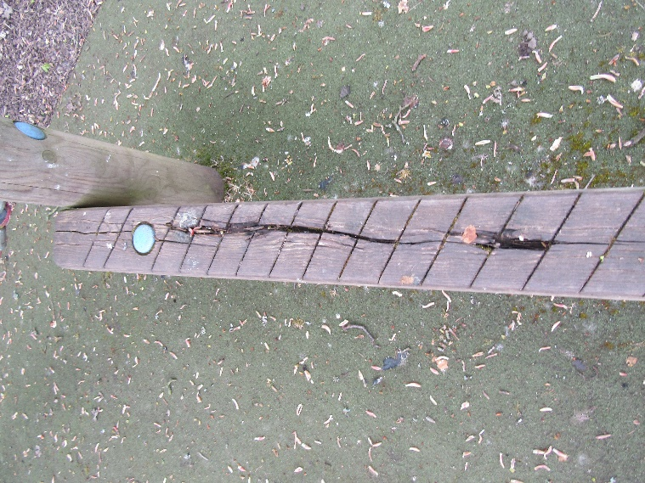
We are now on a mission to replace the school trim trail which is now beginning to show signs of age. We have been repairing sections for a while but ultimately the wood will rot and some parts have already needed to be removed for this reason. Furthermore, the matting that the trim trail is built on was damaged when they removed the path leading down to the temporary village.

All fundraising efforts will now be directed towards raising the money that is needed to replace the trim trail. We will need to raise about £35,000 to replace the trim trail. I am currently applying for grants from a variety of organisations. This is a big target but if we put all efforts into raising funds for this project then it will help.

The children are working with me to design the new trim trail so they get the level of challenge they want. All children have given their thoughts on what they would like to have in the design. Now we need to raise the money!
SingTogether!
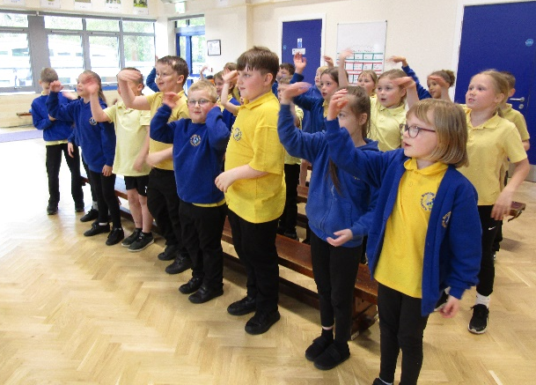
Class 4 have an amazing multi-school choir performance coming up later this month. Lydia has sent out ticket information as numbers will be limited due to BVPS acting as the venue for the performance for the four schools involved. An amazing opportunity and great to see more collaboration between schools.
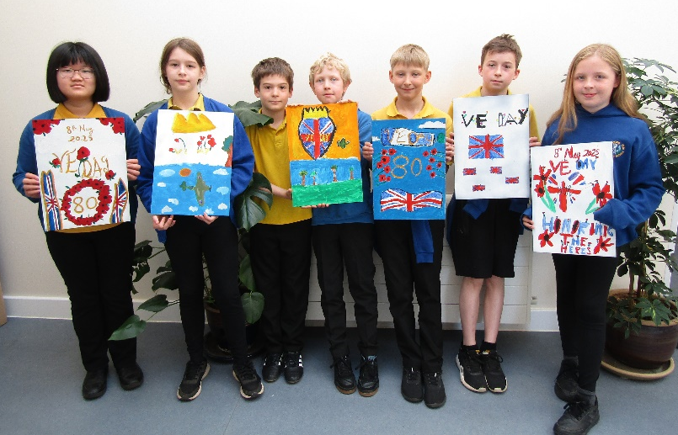
Victory in Europe 80th Celebration
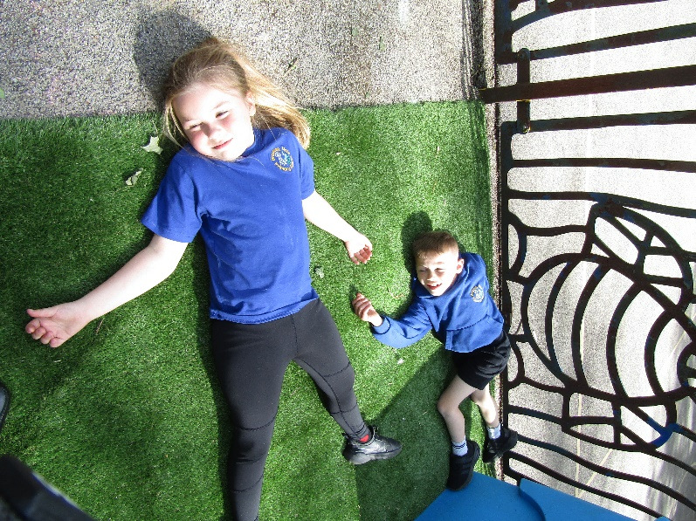
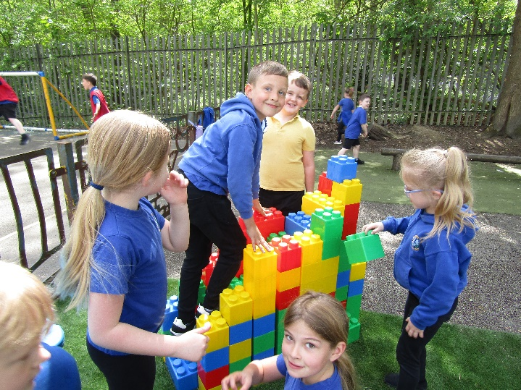
There is an event at the Glapwell Centre this Sunday to celebrate Victory in Europe in WW2. Amazing to think this was 80 years ago and rather sad that conflicts are still very much in the news. Some of our children produced some celebratory artwork for the event at Glapwell. Please see the flyer attached for details.
Have a great Bank Holiday weekend!

Yours sincerely
Mr Rumsby

